Lab 4：MATLAB Programming

Authors | Name：何衍宁 Student ID:12311512  Name：夏天 Student ID:12311610
Objective
Lab4
In Lab 4, our primary learning objectives are centered around deepening our understanding of frequency-domain analysis through the use of the continuous-time Fourier transform (CTFT). We aim to develop a strong grasp of how to analyze both periodic and aperiodic signals in the frequency domain, which simplifies the structure of complex time-domain signals. By engaging with various exercises, we will enhance our intuitive understanding of the relationship between time-domain and frequency-domain properties, particularly in the context of linear time-invariant (LTI) systems. Additionally, we will explore practical applications such as using frequency response analyses to understand system behaviors and applying numerical methods to approximate the CTFT. This lab will not only strengthen our theoretical knowledge but also improve our practical skills in handling real-world signal processing challenges.
Lab results & Analysis
4.2
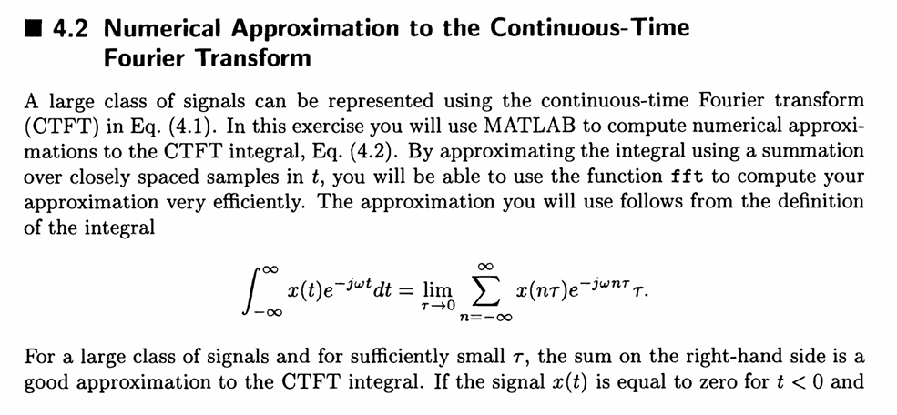

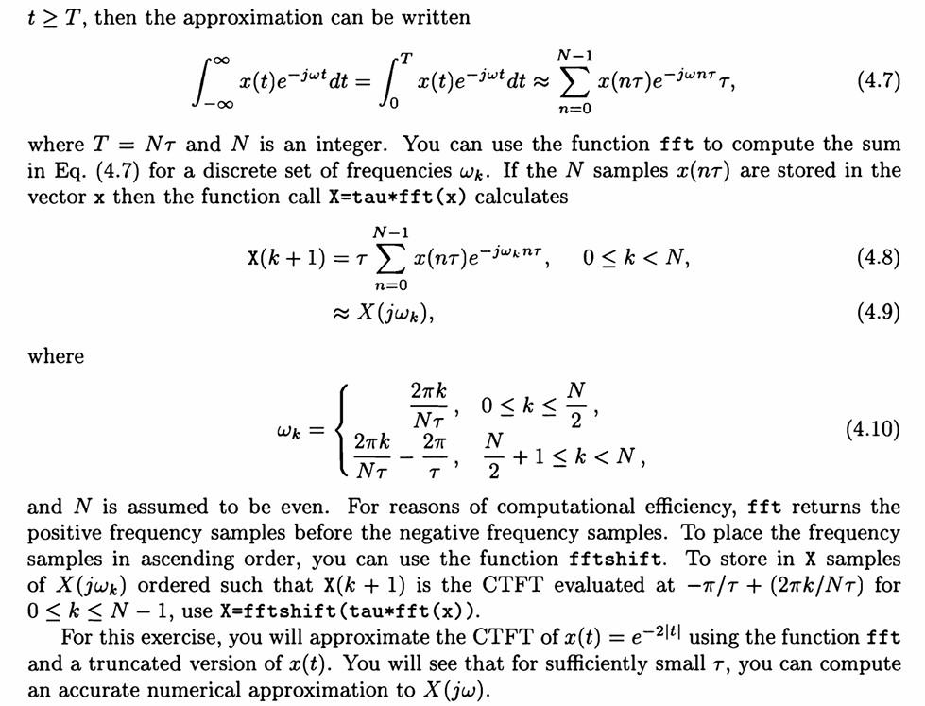
4.2 a
Basic Problems
(a). Find an analytic expression for the CTFT of x(t) = e^{-21tl}. You may find it helpful to think of x(t) = g(t) + g(-t), where g(t) = e^{-2t}u(t).
Find the analytic CTFT expression for x(t)=exp(-2*abs(t))
Analysis:
Think of x(t) as exp(-2*t)*u(t)+exp(2*t)*u(-t).
This question needs no code.
Lab result:
X(j*w) = 1/(2+j*w) +1/(2-j*w)
4.2 b
Let y(t) = x(t-5) and calculate the CTFT expression for y(t), where tau=0.01 and T=10
(b). Create a vector containing samples of the signal y(t) = x(t - 5) for τ = 0.01 and T = 10 over the range t=[O:tau:T-tau]. Since x(t) is effectively zero for |t| > 5, you can calculate the CTFT of the signal y(t) = x(t - 5) from the above analysis using N = T/τ. Your vector y should have length N.
Analysis:
N = T/tau, when N is even, use fft method; At the same time, find the value of |Y(jw)| and plot
clear;
clc;
t = 0:0.01:10-0.01
tau = 0.01;
N = 10/tau;
y = exp(-2*abs((t-5)))
Y_temp = tau*fft(y)
w = -pi/tau + (0:N-1)*2*pi/(N*tau)
Xa = 1./(2+1j.*w) + 1./(2-1j.*w);
Ya = exp(-1j*5*w).*Xa;
subplot(2,1,1),
plot(t,y);
xlabel('t'),
ylabel('y(t)'),
legend('y(t)');
subplot(2,1,2),
plot(w,abs(Ya));
xlabel('\omega'),
ylabel('\omega'),
legend('|Y(j\omega)|');
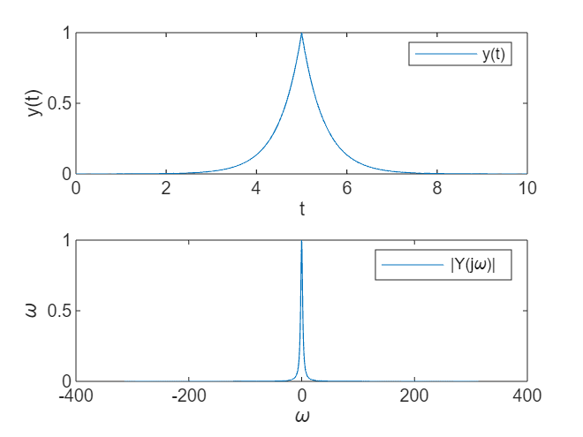

Lab result:
The Y(jw) is like the figure.

4.2 c
Use fftshift method to transform Y
(c). Calculate samples Y(jwk) by typing Y=fftshift(tau*fft (y) ).
Analysis:
Use the fftshift method
t = 0:0.01:10-0.01
tau = 0.01;
N = 10/tau;
y = exp(-2*abs((t-5)))
Y = fftshift(tau*fft(y))
figure
plot(t,abs(Y));
title('Y amplitude figure '),
xlabel('\omega'),
ylabel('abs(Y)');

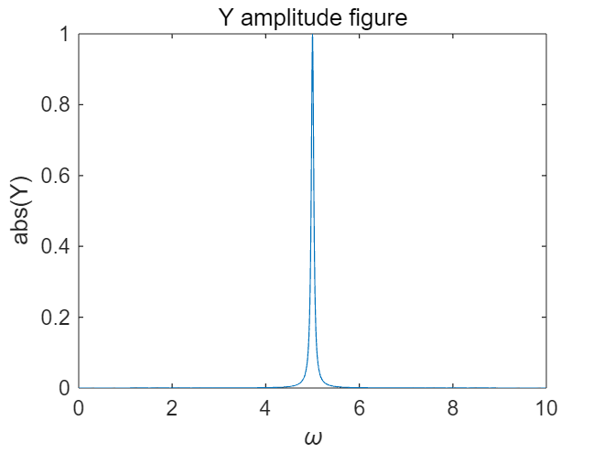

Lab result:
Y(jw) is like the figure.

4.2 d
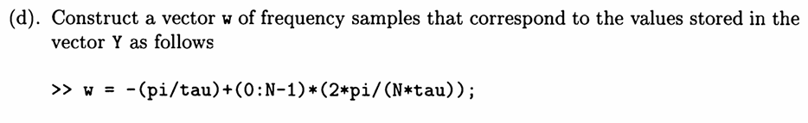
Determine the range w of the frequency sample
Analysis:
We have the formula
clear;
clc;
t = 0:0.01:10-0.01;
tau = 0.01;
N = 10/tau;
y = exp(-2*abs((t-5)));
w = -pi/tau + (0:N-1)*2*pi/(N*tau)

w = 1×1000
-314.1593 -313.5309 -312.9026 -312.2743 -311.6460 -311.0177 -310.3894 -309.7610 -309.1327 -308.5044 -307.8761 -307.2478 -306.6194 -305.9911 -305.3628 -304.7345 -304.1062 -303.4779 -302.8495 -302.2212 -301.5929 -300.9646 -300.3363 -299.7079 -299.0796 -298.4513 -297.8230 -297.1947 -296.5663 -295.9380 -295.3097 -294.6814 -294.0531 -293.4248 -292.7964 -292.1681 -291.5398 -290.9115 -290.2832 -289.6548 -289.0265 -288.3982 -287.7699 -287.1416 -286.5133 -285.8849 -285.2566 -284.6283 -284.0000 -283.3717

Lab result:
We find the \omega.

4.2 e
(e). Since y(t) is related to x(t) through a time shift, the CTFT X(jw) is related to Y(jw) by a linear phase term of the form e^{j5w}. Using the frequency vector w, compute samples of X(jw) directly from Y, storing the result in the vector X.
The time shift corresponds to the frequency domain shift to calculate X from Y
Analysis:
Time shift 5, then the frequency domain is multiplied by exp(j*5*w).
clear;
clc;
t = 0:0.01:10-0.01;
tau = 0.01;
N = 10/tau;
y = exp(-2*abs((t-5)));
w = -pi/tau + (0:N-1)*2*pi/(N*tau);
Y = fftshift(tau*fft(y));
X = Y.*exp(1j.*5*w);
plot(w,abs(X));
title('X amplitude in e'),
xlabel('w'),
ylabel('abs(X');
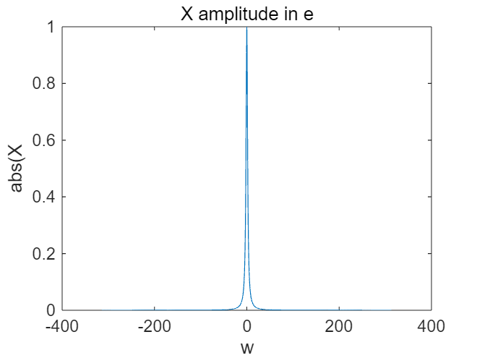

Lab result:
Figure is drawn.

4.2 f
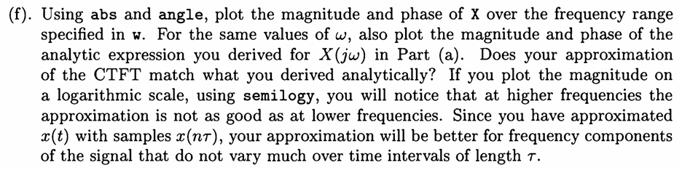
Draw the amplitude and Angle plots of X(jw) in question a and X(jw) in question e respectively
Analysis:
Use w as the range of horizontal coordinates; The difference of X amplitude in a/e problem is compared by using semilogy function of semilog graph.
clear;
clc;
t = 0:0.01:10-0.01;
tau = 0.01;
N = 10/tau;
y = exp(-2*abs((t-5)));
w = -pi/tau + (0:N-1)*2*pi/(N*tau);
Y = fftshift(tau*fft(y));
X = Y.*exp(1j.*5*w);
figure
subplot(2,2,1),
plot(w,abs(X));
title('X magnitude in e'),
xlabel('w'),
ylabel('abs(X)');
subplot(2,2,2),
plot(w,angle(X));
title('X phase in e'),
xlabel('w'),
ylabel('phase(X)');
X1 = 1./(2+1j.*w) + 1./(2-1j.*w);
subplot(2,2,3),
plot(w,abs(X1));
title('X magnitude in a'),
xlabel('w'),
ylabel('abs(X)');
subplot(2,2,4),
plot(w,angle(X1));
title('X phase in a'),
xlabel('w'),
ylabel('phase(X)');

figure
subplot(1,2,1)
plot(w,abs(X))
title('X magnitude in e')
ylabel('abs(X)-e')
xlabel('ω')
ylim([0.001,1])
subplot(1,2,2)
plot(w,abs(X1))
title('X magnitude in a')
ylabel('abs(X)-a')
xlabel('ω')
xlim([-20,20])
ylim([0.001,1])

figure
semilogy(abs(X),abs(X1))
xlabel('w'),
ylabel('abs(X)-e/a')

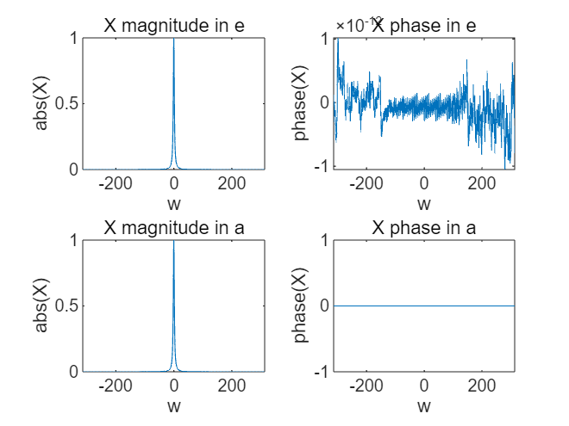
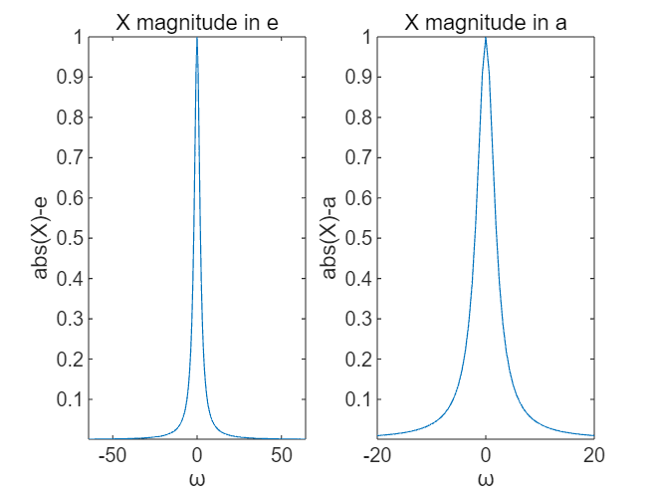
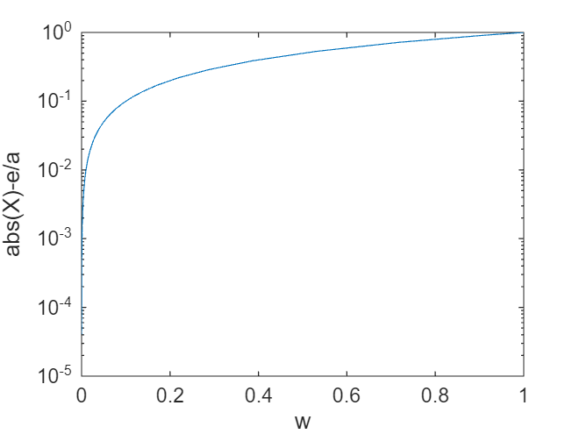

Lab result:
It can be seen from the figure abs(X)-e and abs(X)-a that the approximate value of CTFT is consistent with the answer obtained by analysis, but there are still differences in the specific value. And the amplitude and phase of X are shown in the first four figures. The last figure is about magnitude on a logarithmic scale.

4.2 g
(g). Plot the magnitude and phase of Y using abs and angle. How do they compare with X? Could you have anticipated this result?

Draw the amplitude and phase Angle plots for Y and compare them with X

Analysis:
The time domain signal is time-shifted, and the corresponding frequency domain signal amplitude is unchanged, and the phase Angle is changed

clear;
clc;
t = 0:0.01:10-0.01;
tau = 0.01;
N = 10/tau;
y = exp(-2*abs((t-5)));
w = -pi/tau + (0:N-1)*2*pi/(N*tau);
Y = fftshift(tau*fft(y));
X = Y.*exp(1j.*5*w);
figure
subplot(2,2,1),
plot(w,abs(X));
title('X magnitude'),
xlabel('w'),
ylabel('abs(X)');
subplot(2,2,2),
plot(w,angle(X));
title('X phase'),
xlabel('w'),
ylabel('phase(X)');
subplot(2,2,3),
plot(w,abs(Y));
title('Y magnitude'),
xlabel('w'),
ylabel('abs(X)');
subplot(2,2,4),
plot(w,angle(Y));
title('Y phase'),
xlabel('w'),
ylabel('phase(X)');

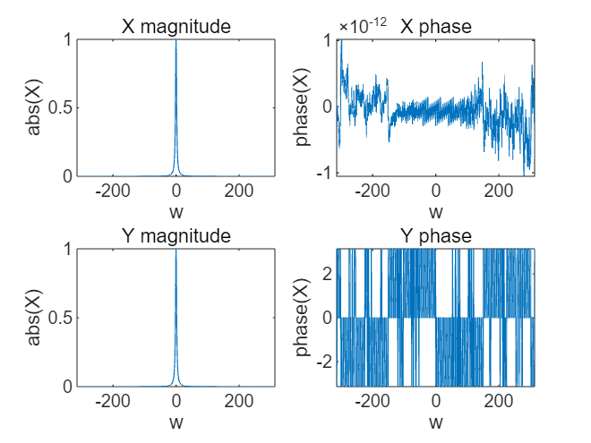

Lab result:
The time domain signal is time-shifted, and the corresponding frequency domain signal amplitude is unchanged, and the phase Angle is changed. As shown in the figure, the amplitude diagram is the same, but the phase Angle diagram is different.

4.6
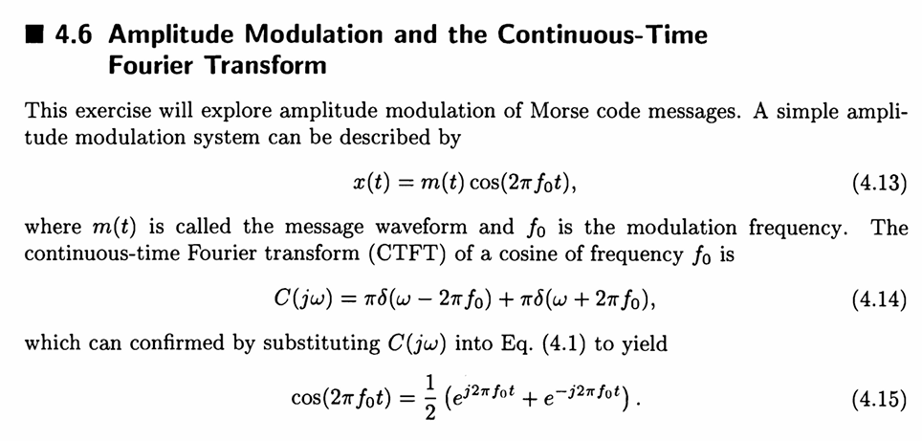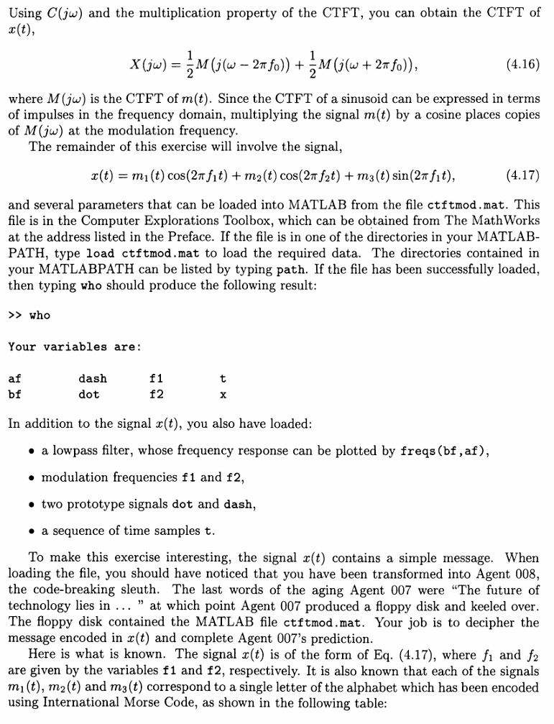
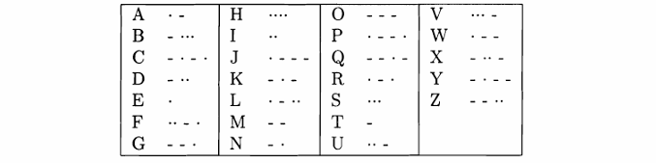

4.6 a
Basic Problems
(a). Using the signals dot and dash, construct the signal that corresponds to the letter 'Z' in Morse code, and plot it against t. As an example, the letter C is constructed by typing c = [dash dot dash dot]. Store your signal z(t) in the vector z.

The question requires the use of signals dot and dush to establish a Morse code representing Z and coexist in z, and it is mapped to t:

Analysis:
Import mod files according to the requirements of the topic, and operate according to the requirements of the topic

clear;
clc;

load newctftmod.mat
z = [dash,dash,dot,dot];
plot(t,z,'LineStyle','-');
grid on,
xlabel('t'),
ylabel('z'),
legend('z');

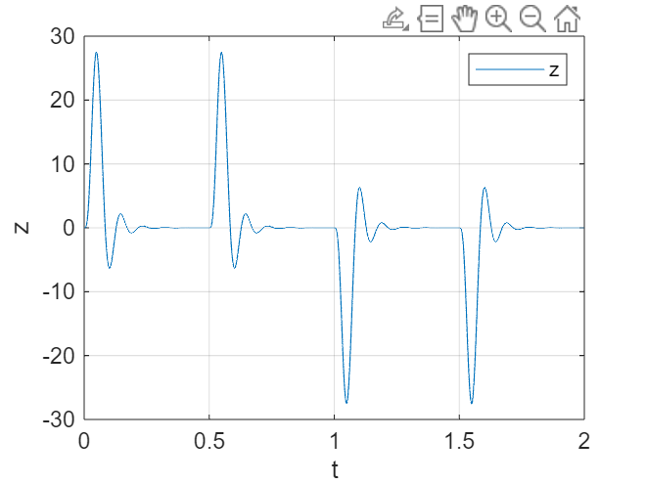

Lab result:
Figure is drawn.

4.6 b

(b). Plot the frequency response of the filter using freqs (bf , af ) .

The problem requires the freqs function to make the frequency response of the filter.
Analysis:
Just follow the instructions of the question
clear;
clc;

load newctftmod.mat;
freqs(af,bf)

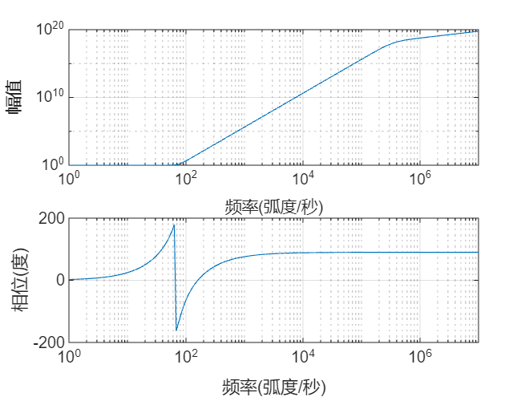

Lab result:
Draw the image as shown.

4.6 c
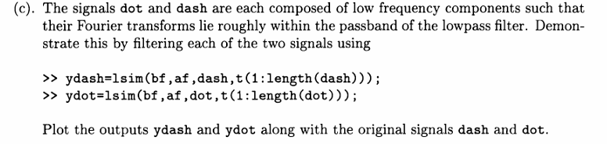

The problem requires filtering dot and dash signals, making images before and after filtering, and proving that dot and dash signals can basically pass through Low-pass filter
Analysis:
Filter with lsim function filter

clear;
clc;

load newctftmod.mat;
ydash = lsim(bf,af,dash,t(1:length(dash)));
ydot = lsim(bf,af,dot,t(1:length(dot)));
figure
subplot(2,1,1)
plot(t(1:length(dash)),dash,t(1:length(dash)),ydash);
xlabel('t'),
ylabel('dash')
grid on;

subplot(2,1,2)
plot(t(1:length(dot)),dot,t(1:length(dot)),ydot);
xlabel('t'),
ylabel('dot')
grid on;
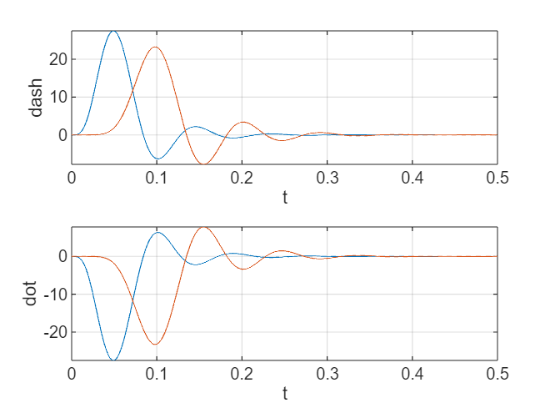

Lab result:
Make the image as shown in the figure, you can see that the two signal waveforms are basically unchanged, the energy loss is small, only the phase change, so it can pass the low-pass filter.

4.6 d

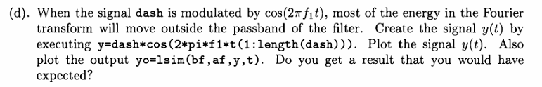

It is required to prove that after the dash signal is modulated by cos(2*pi*f1*t), most of its Fourier transform energy cannot pass through the filter, that is, most of the energy is filtered
Analysis:
Draw y and yo according to the problem.

clear;
clc;

load newctftmod.mat;
ydash = lsim(bf,af,dash,t(1:length(dash)));
ydot = lsim(bf,af,dot,t(1:length(dot)));
y = dash.*cos(2*pi*f1*t(1:length(dash)));
yo = lsim(bf,af,y,t(1:length(y)));
figure
subplot(2,1,1)
plot(t(1:length(dash)),y);
xlabel('t'),
ylabel('y'),
legend('y'),
grid on;
subplot(2,1,2)
plot(t(1:length(dash)),yo);
xlabel('t'),
ylabel('yo'),
legend('yo'),
grid on;

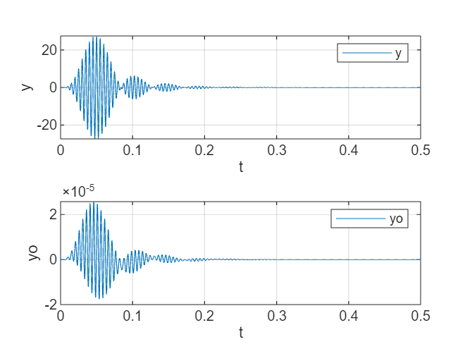

lab result：
The signal waveform is not changed much, but the energy is basically completely lost.

4.6 e
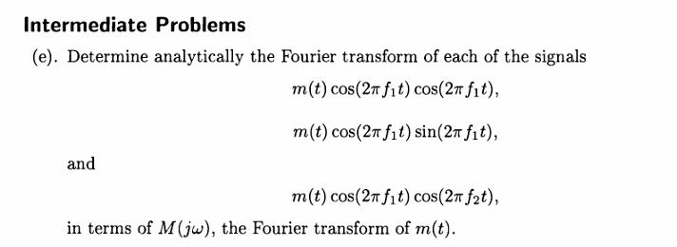

They ask you to find the Fourier transform of three functions analytically
Analysis:
Just solve
This problem needs no code

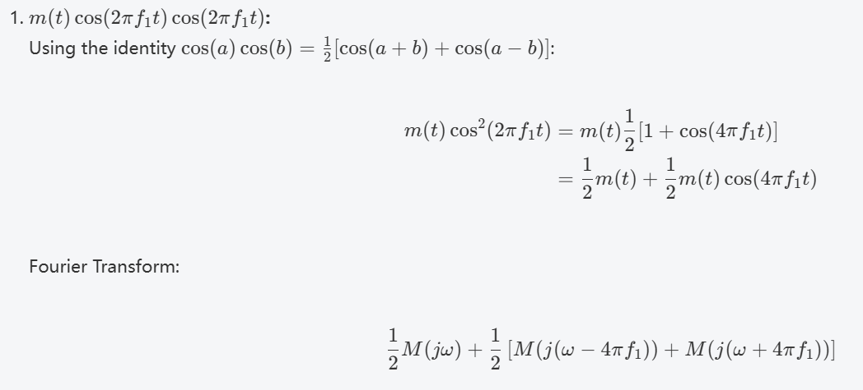
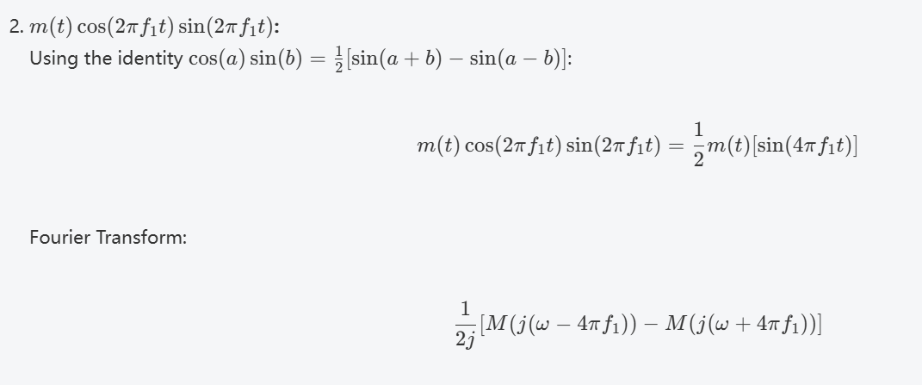
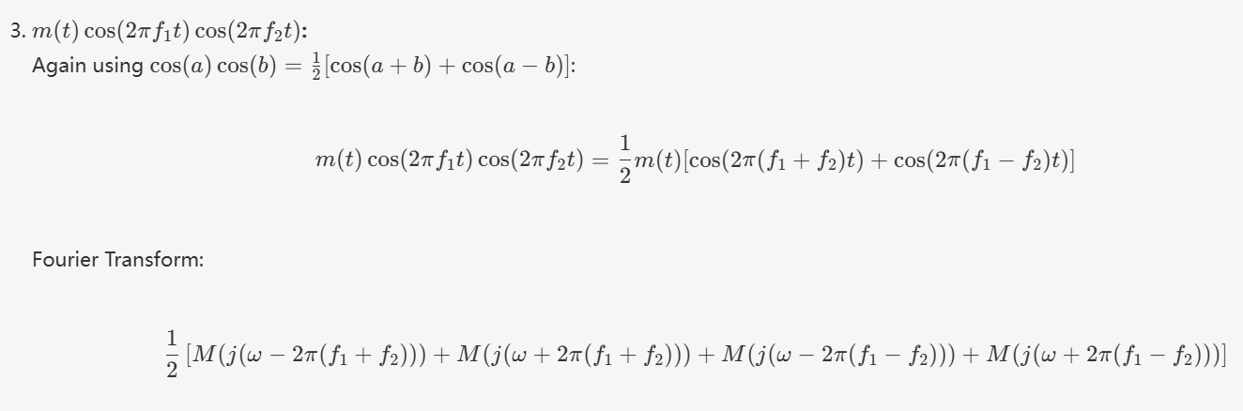
lab result:
The Fourier transform is shown in the figure

4.6 f
(f). Using your results from Part (e) and by examining the frequency response of the Alter as plotted in Part (b), devise a plan for extracting the signal ml (t) from x(t). Plot the signal m1(t) and determine which letter is represented in Morse code by the signal.

The problem asks the design method to extract m1(t) and design m1(t) to identify the letter corresponding to the Morse code of this signal.
Analysis:
From the previous question, we can see that m1(t) in x(t) is modulated by cos(2*pi*f1*t). From the above question, we can see that after multiplying it with the same signal again, the low frequency region can be obtained.
The original signal with the current amplitude halved. Therefore, there is a modulated signal modulating a modulated low-pass filter and the original signal can be restored by doubling the amplitude.

clear;
clc;

load newctftmod.mat;
m1t = x.*cos(2*pi*f1*t);
m1 = 2*lsim(bf,af,m1t,t);
figure
plot(t,m1);
xlabel('t'),
ylabel('m1'),
legend('m1'),
grid on;

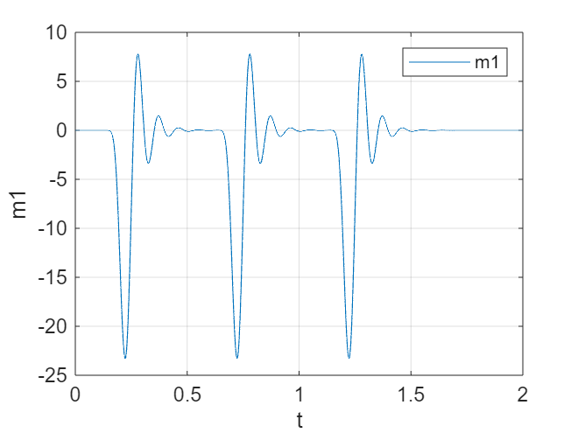

lab result:
From the textbook diagram, we can see that the Moss code stands for S

4.6 g
(g). Repeat Part (f) for the signals m2(t) and m3(t). Agent 008, where does the future of technology lie?
The question asks to reproduce m2(t) and m3(t) in the same way, and to restore the last words of Agent 008.
Analysis:
Same as f.
clear;
clc;

load newctftmod.mat;
m1t = x.*cos(2*pi*f1*t);
m1 = 2*lsim(bf,af,m1t,t);
figure
plot(t,m1);
xlabel('t'),
ylabel('m1'),
legend('m1'),
grid on;

m2t = x.*sin(2*pi*f2*t);
m2 = 2*lsim(bf,af,m2t,t);
figure
plot(t,m2);
xlabel('t'),
ylabel('m2'),
legend('m2'),
grid on;

m3t = x.*sin(2*pi*f1*t);
m3 = 2*lsim(bf,af,m3t,t);
figure
plot(t,m1);
xlabel('t'),
ylabel('m3'),
legend('m3'),
grid on;

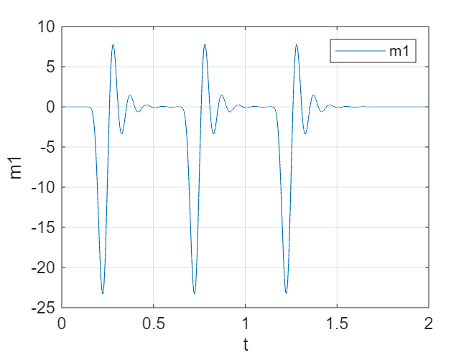
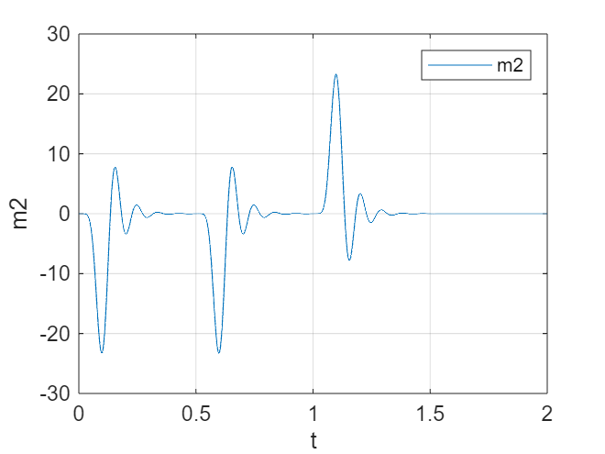
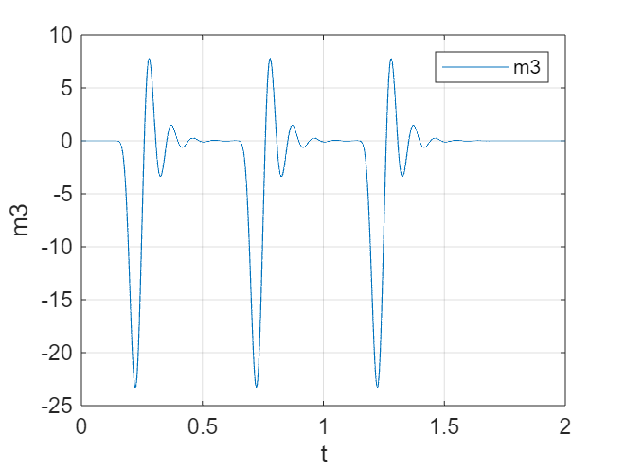

lab result:
After comparison, the Moss codes corresponding to m2 and m3 are ..- And…, correspond to The letters U and S , so Agent008's last words are: "The future of technology lies in SUS." The future of technology lies in SUSTech

Note: Please indicate meaning of the symbols in all expressions. Please indicate the coordinate and unit in all figures.
Experience
- The mathematical foundation required for understanding the CTFT can be quite complex, especially for those new to signal processing. To address this, we will focus on building a strong conceptual understanding through step-by-step tutorials and hands-on exercises. Engaging with additional resources such as instructional videos, and collaborative study sessions can also help in demystifying the more intricate parts of the theory.
- Applying theoretical concepts of the CTFT to real-world problems can be challenging due to the abstract nature of frequency-domain analysis. To bridge this gap, we will use simulation tools and software to visualize the effects of transformations and to conduct practical experiments. This hands-on approach will help us see the direct impact of theoretical principles in practical scenarios, enhancing our learning experience.
- The use of software tools and functions like freqs and fourier for computing CTFTs and analyzing system responses requires some familiarity with numerical computation. To overcome this challenge, we will provide detailed guidelines and practice exercises focusing on these tools. Learning these computational techniques in a step-by-step manner will equip us with the necessary skills to effectively use technology in analyzing and solving signal processing problems.
Score | 100/100

字体：英文Times new Roman；

